Examining the past 50 years of Nutrition and Food Pyramid
Student Name
Course Name/Number
22nd October, 2017

The past 50 years in Nutrition: Why the food pyramid of the 70’s had it all wrong…and how we are paying for it.

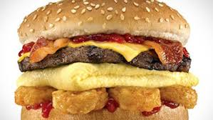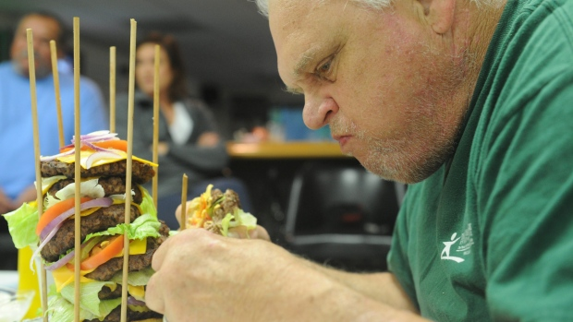
http://www.wcvb.com/image/view/-/20515642/medRes/4/-/maxh/460/maxw/620/-/gts7wgz/-/Gross-Foods---Carls-Jr-Breakfast-Burger-http://www.cbc.ca/gfx/topvideo/2014/elke-burger-challenge.jpgjpg.jpg

#1 What if it’s all been a big fat lie?
http://www.nytimes.com/2002/07/07/magazine/what-if-it-s-all-been-a-big-fat-lie.html?pagewanted=all
- When did Atkins publish his “Diet Revolution” book? In the year 1972
- According to the Atkins diet what has been causing the rise in obesity in America? High carbohydrates and low fat content foods.
- Walter Willett, chairman of the department of nutrition at the Harvard School of Public Health, may be the most visible proponent of testing his “heretic” hypothesis. According to his research, when did the obesity (and diabetes) epidemic being? in the 1980’s
- What is endocrinology? Study of endocrine within the branch of medicine.
- According to David Ludwig, a researcher at Harvard Medical School who runs the pediatric obesity clinic at Children's Hospital Boston, “Endocrinology 101” requires an understanding of how carbohydrates affect what? The effects of carbohydrates on blood sugar on fat metabolism.
- Why does the author claim that “it's possible to find at least some published research to support virtually any theory”? Controllable studies with minimal costs result to unreliable experiments which result to inaccurate results.
- Type 2 diabetes often accompanies obesity. It used to be called adult-onset diabetes and now, for the obvious reason, is not. Why? Type 2 diabetes is now more common in children as it is caused by inappropriate lifestyle such as eating junk foods and lack of exercise.
- Compare the thrifty gene to the spendthrift gene. Thrifty gene examines how frequent famine enabled people in the early days to store extra calories giving them an evolutionary advantage. Spendthrift gene on the other hand focuses on the effortless advantages of losing weight.
- Why is this theory of weight gain and inability to lose weight and keep it off untestable? The huge number of population offers the theory an inability to be testable. In addition, violation of peoples’ rights is a challenge.
- It is also undeniable, note students of Endocrinology 101, that mankind never evolved to eat a diet high in ______starch_________________
- Until the late 70's, the accepted wisdom was that fat and protein protected against overeating by making you______sated________
- It was Ancel Keys, paradoxically, who introduced the low-fat-is-good-health dogma in the 50's with his theory that dietary fat does what? Results to increased cholesterol levels in the body leading to heart diseases.

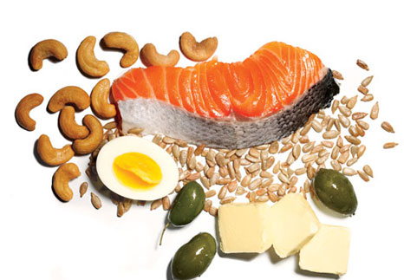
http://femalefitnesstrickytips.com/wp-content/uploads/2013/01/which-are-bad-fats-281x300.jpg
http://www.womenshealthmag.com/sites/womenshealthmag.com/files/images/1205-fat.jpg

#2 The truth about fats: the good, the bad, and the in-between

http://www.health.harvard.edu/staying-healthy/the-truth-about-fats-bad-and-good
- Why did a switch in low fat foods not make the public healthier? Inadequate consumption of much needed healthy fats in the body resulted to deficiencies.
- Why are fats necessary in our diet? Help as the major sources of energy in the body.
- What are the “bad” fats and “good” fats? Bad fats are industrial made fats produced through hydrogenation whilst good fats are originate from vegetables, nuts and fish containing less hydrogen atoms.
- With regard to structure, what makes one fat different from another? Differences occur based on the number of hydrogen atoms within a single carbon atom. Whilst saturated atoms holds maximized hydrogen atoms, good fats holds minimal fats.
- What is hydrogenation and what is it’s the purpose? Entails process that involves using hydrogen and heavy metal catalysts to heat vegetable oils in order to add hydrogen atoms in carbon chains to solidify and prevent from getting rancid.
- What is the safe level of consumption for trans fats? There exists no safe consumption level of trans fats. Any percentage can cause risk of heart diseases.
- Healthy fats are generally __liquid____at room temperature
- What are the differenes between monounsaturated and polyunsaturaded fats? Whilst monounsaturated fats are heart friendly, polyunsaturaded fats result to unhealthy effects to the body. Monounsaturated fats have single to single carbon bonds while polyunsaturaded fats experience at least two carbon bonds.
- Olive oil is an example of a ___mono_______unsaturated fat.
- Fats that your body can not make but are required for normal bodily functions are called what? Essential fats
- What are the two main types of polyunsaturated fats?(2 points) Omega 6 and omega 3 fatty acids

#3 The Great Grain Conundrum
http://toxipedia.org/download/attachments/17044484/Report%20%2318%20-%20Great%20Grain%20Conundrum.pdf?version=1&modificationDate=1388194221000&api=v2
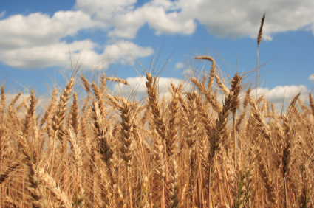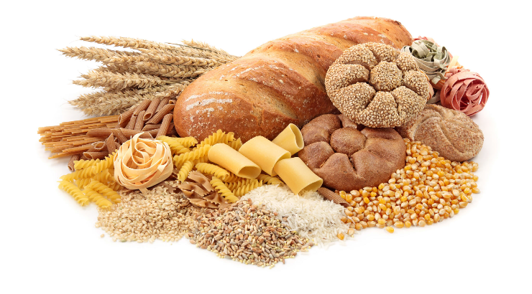https://encrypted-tbn0.gstatic.com/images?q=tbn:ANd9GcSQEp_JdL-a3jL9vnNn0PpcW2qrfxvz5IHe9DZcOb5nqiiyLUFtdA,http://bonfirehealth.com/wp-content/uploads/2011/09/grain.jpg
- According to the author, how has the scientific community changed it’s position on wheat and other grains? The group has discouraged wheat intake due to the high toxic level effects of grains on human body.
- What are anti-nutrients? Natural compounds that interfere with absorption of nutrients in human body.
- What foods contain phytic acid and what are the 3 adverse effects of this protein? Foods containing phytic acid include grains, seeds, beans and nuts. Effects include; interference with enzymes, inhibiting absorption of minerals in the body and trapping phosphorous hence limiting their presence in the body.
- What probiotic produces phytase? Lactobacilli
- Which antinutrients can contribute to suppression of thyroid activity? Goitrogen compound.
- Gluten is actually a compound of two storage proteins. What are they? Glutelin and Prolamin.
- According to the article, there are several types of gluten which vary from grain to grain. However, by definition “technically” gluten is a term applied specifically to the prolamin-glutelin combination found in what? Refers to the prolamin-glutelin combination.
- Which prolamine has been implicated as the main environment factor in causing Celiac disease? Gliadin
- What is damaged in Celiac disease? Duodenum villi
- Symptoms of Gluten sensitivity are similar to celiac disease. What are these symptoms? Headaches, fatigue, abdominal pain and schizophrenia.
- Gluten molecules are resistant to the enzymes that break down proteins. What are these enzymes called? Peptidases
- According to David (2010) what explains the rise in Celiac disease since the 1960s? Modern wheat contain gluten proteins that considerably differ from those in the 1960.
- What causes a “leaky gut”? An inflammatory effect from gluten which leads to death of the intestinal cells which causes intestinal permeability.
- A leaky gut can allow ___bacterial proteins_____ and other toxic compounds to enter in to the blood stream and general circulation.
- Gliadin can be similar in structure to other proteins found in tissues of such organs as the ___thyroid____ or the _______pancreas____.
- The most common nutritional deficiencies in gluten intolerance and Celiac disease are: Vitamin B12, folate and Iron.
- (Please Scroll down to section entitled: “Amylopectin A”) The most digestible form of amylopectin is amylopectin-A, found in wheat. Because it is the most digestible, it is the form that most rapidly increases blood sugar. This is why, gram for gram, wheat increases _______blood sugar__________ to a greater degree than, say kidney beans or potato chips. Or in other words, wheat products are no better and are often worse, than even simple carbohydrates such as ____sucrose________.
- The higher the blood glucose after consumption of food, the greater the insulin level, the more _____fat____ is deposited.

#4 Leaky gut: what it is and how to heal it
http://health.usnews.com/health-news/blogs/eat-run/2014/03/06/leaky-gut-what-it-is-and-how-to-heal-it
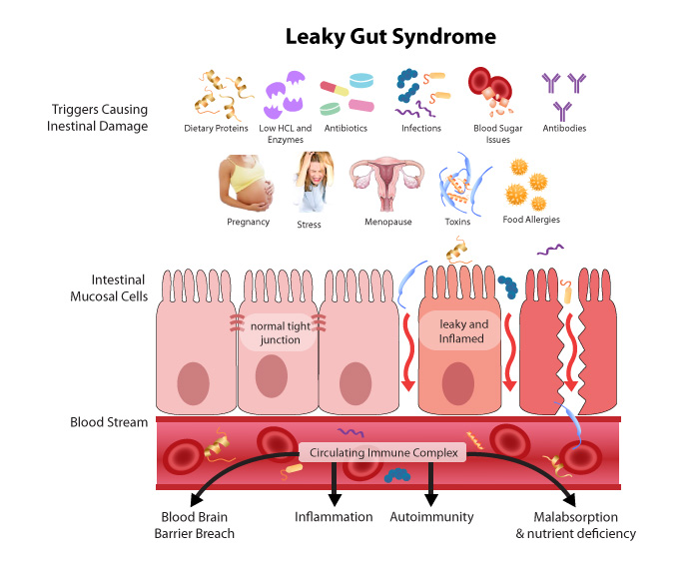

- In order for the vitamins and minerals to be absorbed, the small intestine contains ________ microscopic pores ________________so the nutrients can be transferred into the bloodstream.
- The problem with leaky gut is it causes the pores in your intestine to ___widen________.
- How does an increase in pore size in the intestine lead to allergies? Widening pore sizes allows unwanted substances to flow into the blood stream resulting to an attack response by the immune system which destroy healthy cells leading to allergies.
- According to the article, what are two ways to develop a leaky gut? (2 points) constipation that leads to inflammation and imbalance of flora that causes intestinal pores to open.
- According to the author, what are three ways to heal a leaky gut? Consuming glutamine, taking probiotics and consuming fermented foods

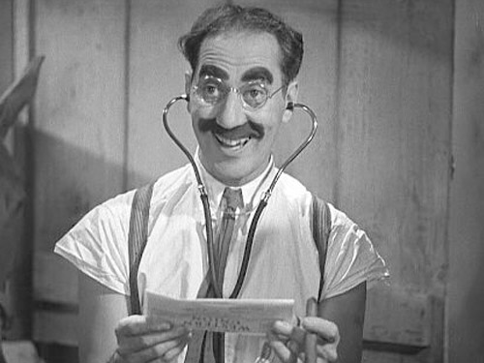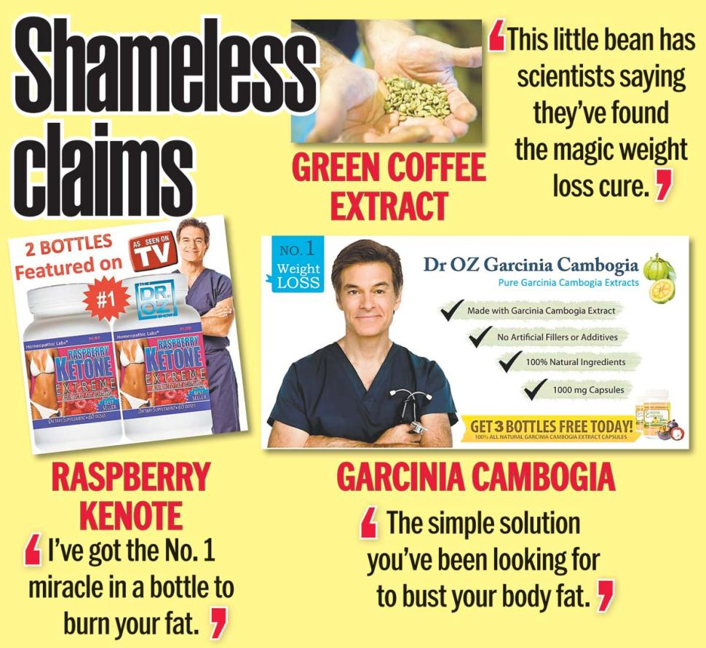
http://12840-presscdn-0-47.pagely.netdna-cdn.com/wp-content/uploads/2014/06/marxundiacarreras.jpg http://maxresultstraining.com/wp-content/uploads/2015/04/dr.-oz-claims.jpg

#5 Quacks or good advice?
http://www.alternet.org/personal-health/four-biggest-quacks-plaguing-america-their-bad-claims-about-science
- Why did the FDA send Dr. Mercola warning letters? FDA did not approve Mercola’s medical claims of being able to cure the claimed diseases.
- According to the author, what are three claims against Mercola?
- The non-existence of AIDS, and that it is not caused by HIV but rather psychological stress on the belief of HIV harm.
- He claimed on the emitting of radiation by microwave ovens.
- He claims further that skin cancer can be caused by commercial sunscreens.
- According to the author, what are three claims against “the health ranger”, Mike Adams?
- Medications but not guns kill people.
- Airplane chemtrails emit lead that affects human health.
- Cold fusion device will likely influence the energy sector.
- According to Dr. David Gorski, Why is the “Food Babe’s” strategy effective?
The audience is illiterate and has less or no understanding of the chemical names hence result to unquestionable support to his claims.
- Gorski says since companies live and die by public perception, it's far easier to “give a blackmailer like Hari what she wants than to try to do what? Than to counter her propaganda via educating the public.
- According to the article, what does Vani Hari claim happens to water when exposed to the word “Hitler”? She claims that water changes its physical property.
- ​Dr. Oz is professor at the Department of Surgery at Columbia University, directs the Cardiovascular Institute and Complementary Medicine Program at New York-Presbyterian Hospital, has authored more than 400 medical research papers and holds several patents. Why is he included in the author’s list of “Quacks”? He takes into account his popularity to create public awareness on inappropriate mechanisms that haven’t been scientifically approved within the education sector.

